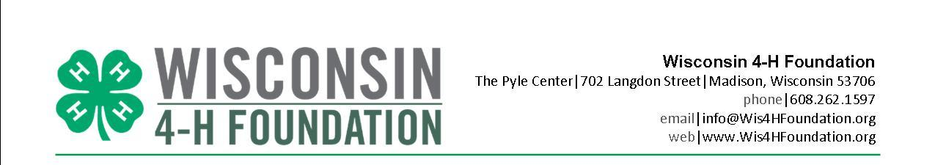

FOR IMMEDIATE RELEASE
For more information contact:
Joanne Wolan
Wisconsin 4-H Foundation
Joanne@Wis4HFoundation.org
608.262.1597

BRING MARCH IN LIKE A LION WITH A 4-H PLATE

Madison, Wis. (March 2019) – Bring March in with a roar by ordering a Wisconsin 4-H license plate for your car, truck or motor home. The specialty plate, now available through the Wisconsin Department of Motor Vehicles, supports the Wisconsin 4-H program, and bears the message 4-H Empowering Youth. The sale of the plate includes a fee that goes to the Wisconsin 4-H Foundation.

“This is a great way for our 4-H families, alumni and supporters to show their fierce love of 4-H,” says Brenda Scheider, Executive Director for the Wisconsin 4-H Foundation. “Half of the proceeds from every plate sale will go back to the county in which the plate was purchased. The other half will be used for state and regional 4-H programs.”

Vehicles that​​ qualify for the 4-H license plate include:
- automobiles
- motor homes (annual registration only)
- motor trucks
  - 4,500, 6,000 or 8,000 pounds gross weight including dual purpose farm and dual purpose motor home
  - 12,000 pounds gross weight farm truck

Persons requesting 4-H Foundation license plates will pay:
- $25 annual donation. The donation may be deductible.
- $15 issuance fee or an annual $15 personalized plate fee, if requested.
- The regular registration fee for the vehicle if the current plates expire within three months or the vehicles has no plates.
At each plate renewal, 4-H supporters will pay the $25 donation and the regular registration fee for non-personalized 4-H license plates. ​

4-H license plates may be personalized by paying a $15 personalized plate fee each year in addition to the $25 donation and regular annual registration fee.

Contact the Wisconsin Department of Transportation or go to www.wisconsindot.gov/Documents/formdocs/mv2969.pdf for more information.
The Wisconsin 4-H Foundation exists to provide essential support for the 4-H Youth Development program – a program of the University of Wisconsin Cooperative Extension. Last year, individuals, corporations and foundations provided support for a network of Cooperative Extension staff and more than 20,000 adult and youth volunteers in shaping nearly 150,000 youth who take part in 4-H programs throughout the state.
4-H Foundation supporters provide resources to create cutting-edge, relevant programs for young people to learn real-world skills that will prepare them for the challenges of today and tomorrow, moving communities, the state, our county and the world forward in ways no other youth organization can.
The Wisconsin 4-H Foundation is dedicated to providing funding for 4-H programs that teach young people the skills necessary to become responsible, productive citizens. Hands-on 4-H activities emphasize communication skills, self-confidence, sound decision-making practices, and community concern, all of which prepare today’s youth to be our leaders tomorrow. Find out more about the Wisconsin 4-H Foundation and how you can support our most precious resource, Wisconsin Youth, at www.Wis4HFoundation.org.

###

